Overview of Watermarking with SpecterX

Version 1.0

Issued: 01.25.25
This document is intended to provide understanding of the capabilities and parameters of Watermarking with SpecterX.

Table of Contents
Watermarking with SpecterX 1
Supported File Types & Applications 1
Applying Watermarks through SpecterX Policies 2
Presentation of Watermark 2
Correlating File ID to Access Events 3

Watermarking with SpecterX
Watermarking is an added security feature that can be applied to files shared with SpecterX, designed to discourage data leaks, help organizations trace the source of a breach, and increase awareness to prevent accidental sharing.

Supported File Types & Applications
SpecterX currently supports watermarking of .docx, .pptx, .xlsx, .pdf for both protected encrypted downloads & standard protected files.

Supported files that are shared with a policy that includes watermarking can be opened on any operating system with the following applications:
- Microsoft Office Applications Word, Excel, & Powerpoint.
- Adobe Reader,
- Microsoft Edge

Applying Watermarks through SpecterX Policies
Watermarks are applied at the data layer through policies configured within the SpecterX WebUI. When a SpecterX protection policy that includes watermarking is applied, the watermark will automatically be applied to all future copies of supported file types accessed via SpecterX Secure Links and WebUI. Please note, watermarking cannot be added retroactively to Protected Native Files that have already been downloaded.

Presentation of Watermark
SpecterX Watermarks display in horizontal text across the content of the data with the following attributes:

- Email address of the authorized receiver
- File ID allows for association of file access events through audit log detail.
- Confidential Do Not Distribute Disclaimer

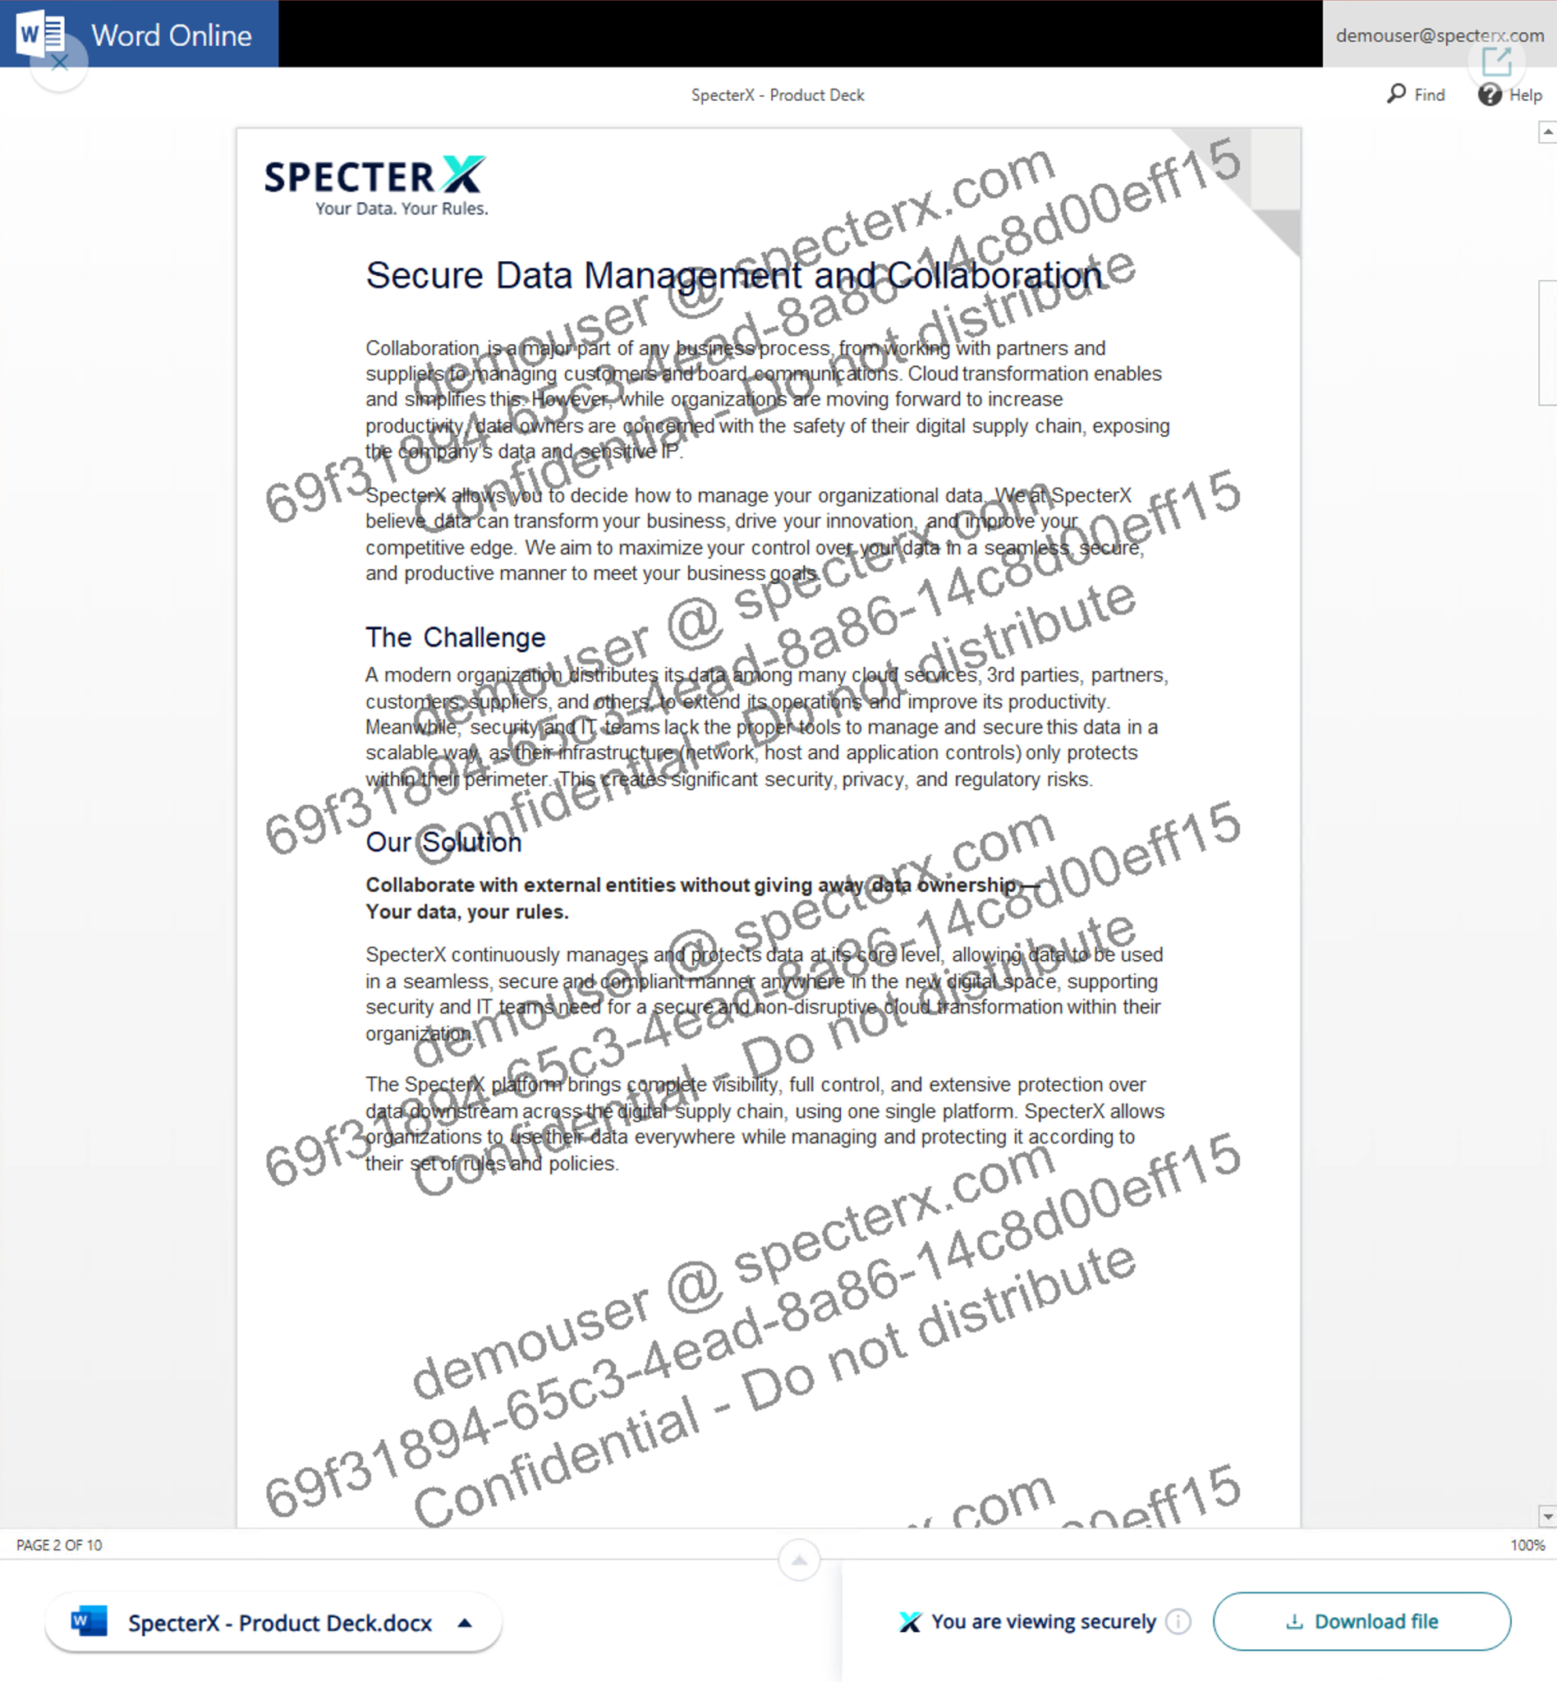
As watermarking is applied at the data layer, coverage of the watermark does not extend to new content or pages added by users that have been given edit privileges of protected downloaded files.

Correlating File ID to Access Events
File ID allows for association of file access events through SpecterX audit logs. File ID and displayed email address audit searches will provide tracking of the file through its lifecycle. SpecterX audit logs records the following attributes:
- Operation Performed such as login, data shared, opened, downloaded, permissions added, or access denied.
  - In access denied events, both email and IP addresses of the user that shared the data and the user that attempted to access it are recorded
- File Name
- Affected Users by permission changes performed
- Policy Name
- The application used to access data
- User IP address, nation of access, and device type
- File ID for reference to specific audit log event record

